US History 8 Second Semester Study Guide

True/False
Indicate whether the statement is true or false.

____ 1. French agents tried to get bribes from the United States and caused a scandal known as the Teapot Dome Scandal.

____ 2. John Adams helped the United States avoid war with Great Britain in 1800.

____ 3. During the troubles with France, Republicans in Congress passed laws to limit immigration and restrict free speech.

____ 4. The debate over states’ rights had been going on since the writing of the Constitution.

____ 5. England closed the port of New Orleans to American farmers.

____ 6. Robert Livingston and James Monroe offered to buy New Orleans, but Tallyrand offered to sell all of Louisiana.

____ 7. The expeditions of Lewis and Clark and of Zebulon Pike expanded Americans’ knowledge of the land west of the Missouri River.

____ 8. Lewis and Clark traveled west across the United States until they reached the Atlantic Ocean.

____ 9. During the War of 1812, Native Americans regained much territory.

____ 10. As a result of the War of 1812, Britain paid the United States 10 million dollars.

____ 11. The economic collapse of the United States after Andrew Jackson left office was the Panic of 1837.

____ 12. South Carolina threatened to withdraw from the Union, or secede.

____ 13. New Hampshire tried to nullify laws raising tariffs.

____ 14. The Age of Jackson ended when Martin Van Buren lost the election of 1824.

____ 15. Andrew Jackson opposed the Congress because he believed it gave too much power to the wealthy.

____ 16. Americans in the mid-1800s thought of the Great Plains as “the Far West.”

____ 17. In 1800, the United States was not the only nation to claim the West.

____ 18. Manifest Destiny refers to the idea that the United States should stretch across the
entire continent.

____ 19. The Spanish, like Father Junípero Serra, built creoles in California.

____ 20. In their search for gold, mountain men explored much new territory in the West.

____ 21. The first Americans to move into the Far West were farmers.

____ 22. Thousands of people suffered many hardships on the Santa Fe Trail to reach the
Northwest.

____ 23. Women in the West had higher status than women in other parts of the country.

____ 24. More than 80,000 people traveled to Alaska during the gold rush in 1849.

____ 25. During the gold rush, the Native American population in California fell from about
150,000 to only about 50,000.

____ 26. Tales of a “mountain of gold” attracted thousands of Chinese to California.

____ 27. The Mormons moved to California in search of freedom of religion.

____ 28. The goal of the new Federalist Party was to stop the spread of slavery into the western
territories.

____ 29. Stephen Douglas took a strong stand against slavery’s expansion in the
Lincoln-Douglas debates.

____ 30. Roger B. Taney was the Chief Justice of the Supreme Court who wrote that Dred Scott
was not a free man.

____ 31. Northerners supported John Brown.

____ 32. Northern reaction to John Brown’s raid shocked and angered southern African Americans.

____ 33. In northern states, dissenters called abolitionists spoke out against the war.

____ 34. In the South, strong beliefs in military service caused some governors to object to their
troops’ being commanded by officers from other states.

____ 35. Both the North and the South had draft laws.

____ 36. The Union blockade prevented the South from gaining money by selling rice overseas.

____ 37. During the Civil War, some women worked in factories making ammunition.

Multiple Choice
Identify the choice that best completes the statement or answers the question.

Directions: Use the quotation to answer the following questions.

Thomas Jefferson, 1798 “They have brought into the lower house a sedition bill, which . . . undertakes to make printing certain matters criminal. . . . Indeed this bill and the alien bill both are so [against] the Constitution as to show they mean to pay no respect to it.”

____ 38. What are the “certain matters” that Jefferson is referring to in this quote?
a. | printing editorials in favor of the French Revolution
b. | printing bonds
c. | printing more money
d. | printing criticism of the government

____ 39. What did Thomas Jefferson mean when he said that the bills referred to in this quote were against the Constitution?
a. | They made it possible for members of foreign powers to be represented in Congress.
b. | They placed the rights of states ahead of the authority of the federal government.
c. | They violated constitutional rights, especially the rights of speech and the press guaranteed by the First Amendment.
d. | They reduced the powers of the Supreme Court and disrupted the government’s system of checks and balances.

____ 40. In his Farewell Address, George Washington advised against becoming involved in European affairs because
a. | he opposed foreign trade.
b. | France was too weak to aid the United States in battle.
c. | he did not want the United States to be dragged into war.
d. | the British in the Northwest Territory were allies.

____ 41. Federalists were supported by all of the following EXCEPT
a. | merchants.
b. | workers who depended on manufacturing and trade for their jobs.
c. | property owners.
d. | farmers.

____ 42. Which of the following was a function of the National Bank?
a. | to be a safe place for deposits of government funds
b. | to eliminate the use of paper currency
c. | to impose and collect taxes
d. | to lend the government money

____ 43. Washington’s response to the Whiskey Rebellion
a. | led to a reduction of the excise tax.
b. | supported the doctrine of states’ rights.
c. | proved the strength of the national government.
d. | confirmed the rights of individuals to protest unfair laws.

____ 44. How was the French Revolution like the American Revolution?
a. | Both began as a fight against monarchy and inequality.
b. | Both advocated violence against the king and queen.
c. | Both were revolts against trade with the British.
d. | Both resulted from neutrality in foreign relations.

____ 45. Which of the following individuals had the greatest impact on the economic policy of the Washington administration?
a. | Alexander Hamilton | c. | Henry Knox
b. | John Adams | d. | Thomas Jefferson

Directions: Use this map and your knowledge of social studies to answer the following questions.

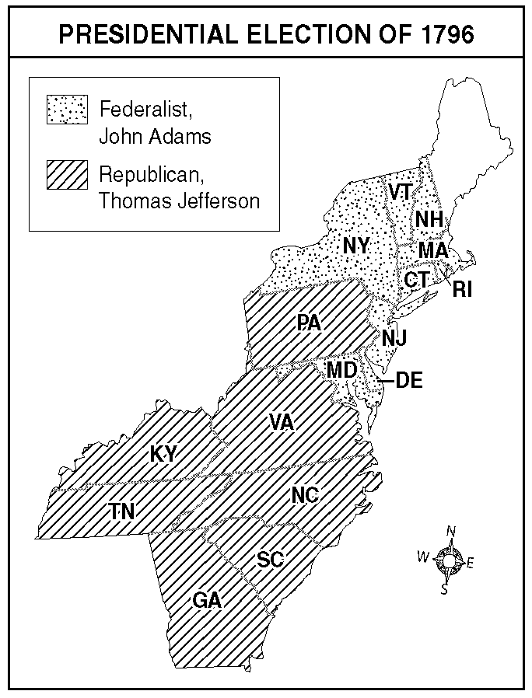

____ 46. Which statement is BEST supported by the map?
a. | Votes throughout the country were evenly split in support of both parties.
b. | Federalists had strong support in the South.
c. | Republicans received no votes in the North.
d. | Federalists won the election.

____ 47. What does the map illustrate about growing political tensions in the nation?
a. | Voters in every region agreed on the direction the nation should take.
b. | Voters followed George Washington’s warning against the formation of Political Parties.
c. | Different interests and political views were dividing regions of the country.
d. | Southern voters protested Federalist policies by refusing to vote in the election.

Alexander Hamilton
• wanted the U.S. government to pay all federal and state debts.
• proposed a national bank.
• supported a high tax on imports.
• argued for a “loose” interpretation of the Constitution.
• expressed ideas opposed by southerners.
• expressed ideas opposed by Thomas Jefferson.

Use the information in the box and your knowledge of social studies to answer the following questions.

____ 48. Why did many Southerners oppose Hamilton’s financial plan?
a. | They were against all federal taxes.
b. | They believed banks were unnecessary.
c. | Their states had paid off their war debts already.
d. | They wanted Thomas Jefferson to be president.

____ 49. Why did southern members of Congress agree to support Hamilton’s plan?
a. | The nation’s new capital would be built in the South.
b. | The violence of the Whiskey Rebellion had alarmed them.
c. | Congress also imposed a high tax on farmers in Pennsylvania.
d. | George Washington asked them to do so.

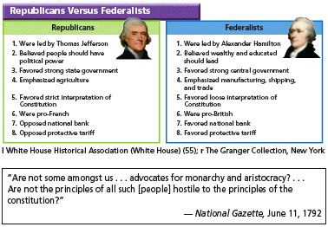

l White House Historical Association (White House) (55);
r The Granger Collection, New York

Use the information in the chart and the excerpt to answer the following question.

____ 50. Which statement describes the point of view of the writer in the National Gazette?
a. | The writer supports the Federalists.
b. | The writer supports the Republicans.
c. | The writer supports neither political party.
d. | The writer’s point of view is not clear from the quote.

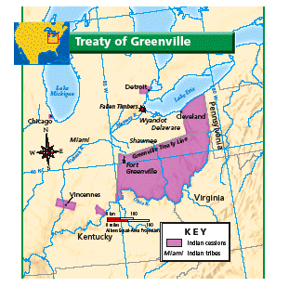

Use the map and your knowledge of social studies to answer the following questions.

____ 51. Under the treaty that ended the American Revolution, the area from the Appalachian Mountains to the Mississippi
a. | was set aside for Native Americans.
b. | was granted to the British.
c. | belonged to the United States.
d. | was governed jointly by Britain and the United States.

____ 52. What happened as a result of the Treaty of Greenville?
a. | The United States won the Battle of Fallen Timbers.
b. | Native Americans were resettled onto lands around the Ohio River.
c. | Native Americans gave up their lands in Kentucky.
d. | More American settlers moved onto lands north of the Ohio River.

The Sedition Act
• was supported by the Federalists.
• made it a crime to write or say anything insulting or false against the President, Congress, or the government.
• punished violators with fines up to $2,000 and prison sentences of up to two years.
• led to ten convictions in 1798 and 1799.

Use the information in the box and your knowledge of social studies to answer the following questions.

____ 53. According to the Republicans, what did the Sedition Act violate?
a. | the First Amendment | c. | the Alien Acts
b. | the Third Amendment | d. | the Kentucky and Virginia resolutions

____ 54. What other issue divided Republicans and Federalists during John Adam’s presidency?
a. | treatment of Native Americans | c. | the Alien Acts
b. | Jay’s treaty | d. | western expansion

Directions: Use the quotation and your knowledge of social studies to answer the questions.

“This war [of 1812], if carried on successfully, will have its advantages.” — Felix Grundy, Representative from Tennessee, speaking in Congress in December of 1811.

____ 55. Who would have been MOST likely to disagree with Grundy’s position?
a. | a settler in Kentucky | c. | a War Hawk from North Carolina
b. | a soldier in Indiana | d. | a merchant from New Hampshire

____ 56. The Sedition Act punished people who openly criticized the government. When Thomas Jefferson took office,
a. | he founded a newspaper to publish information about the executive branch.
b. | he released people who had been imprisoned under the Sedition Act.
c. | he signed a bill authorizing special privileges for newspaper editors and reporters.
d. | he supported the passage of a “freedom of the press” bill in Congress.

____ 57. From which foreign nation did the United States purchase Louisiana?
a. | Spain | c. | France
b. | Great Britain | d. | Haiti

____ 58. Thomas Jefferson was uneasy about purchasing the Louisiana Territory because
a. | he did not have the constitutional power to buy land from another country.
b. | he worried about angering farmers who shipped their crops to New Orleans.
c. | he did not trust Monroe and Livingston to make a favorable deal.
d. | he worried that the land in the territory would be of poor quality.

____ 59. Which of the following is an example of judicial review?
a. | Congress votes to approve a Supreme Court appointment.
b. | A newspaper editorial criticizes a Supreme Court decision.
c. | A decision by a lower court is appealed to the Supreme Court.
d. | The Supreme Court rules that a new law violates the Constitution.

____ 60. Which action BEST reflects Jefferson’s determination to reduce the size and power of the federal government?
a. | He kept the National Bank open.
b. | He cut federal spending.
c. | He continued to pay off the national debt.
d. | He allowed many Federalists to keep their government jobs.

____ 61. The Mississippi River was especially important to farmers because it
a. | encouraged new settlers to come north on barges and steamboats.
b. | was a barrier protecting them from Native American attacks.
c. | allowed them to ship their crops to market in New Orleans.
d. | blocked the westward expansion of the United States.

Directions: Use this map and your knowledge of social studies to answer the following questions.

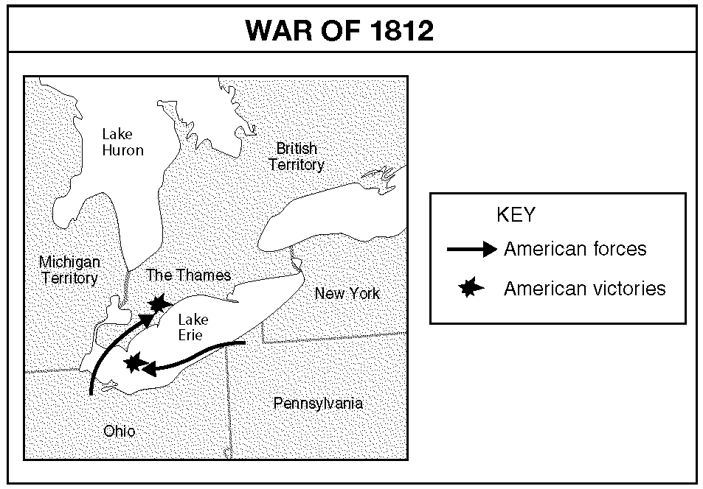

____ 62. Which statement is BEST supported by the information on the map?
a. | The British won major victories at the battles shown.
b. | No major battles took place west of New York.
c. | The United States won victories at the battles shown.
d. | Each side suffered a major loss at one of the battles shown.

“Let us, then, fellow-citizens, unite with one heart and one mind. . . . But every difference of opinion is not a difference of principle. We have called by different names brethren [members of a society] of the same principle. We are all Republicans, we are all Federalists. . . .
“What more is necessary to make us a happy and prosperous people?. . . . a wise and frugal Government, which shall restrain men from injuring one another, shall leave them otherwise free to regulate their own pursuits of industry and improvement, and shall not take from the mouth of labor the bread it has earned. This is the sum of good government. . . .”
— Jefferson’s Inaugural Address, 1801

Use the information in the box and your knowledge of social studies to answer the following questions.

____ 63. Based on the excerpt, Jefferson
a. | expected Federalists to flee the country.
b. | wanted to have good relations with Federalists.
c. | intended to crack down on corrupt officials.
d. | believed that differences between Republicans and Federalists were widening.

____ 64. Which of the following statements reflects Jefferson’s ideas as expressed in the excerpt?
a. | The United States needs a larger military.
b. | Federal powers must be increased.
c. | Government expenses should be reduced.
d. | The government should regulate businesses in order to protect laborers.

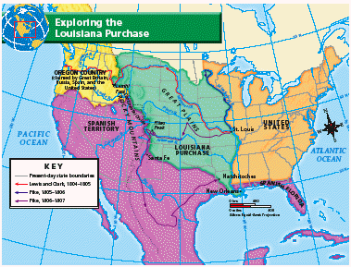

Use the map and your knowledge of social studies to answer the following questions.

____ 65. Among the natural features that mark the boundary of the Louisiana Purchase are the
a. | Mississippi River and the Columbia River.
b. | Mississippi River and the Pacific Ocean.
c. | Mississippi River and the Continental Divide.
d. | Missouri River and the Continental Divide.

____ 66. Which country probably felt most threatened by American explorations?
a. | Great Britain | c. | France
b. | Russia | d. | Spain

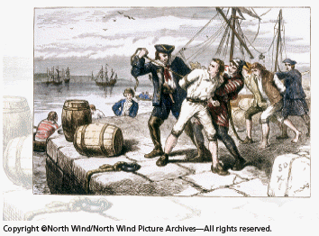

Use the picture and your knowledge of social studies to answer the following question.

____ 67. What was one way Jefferson responded to the impressment of American sailors?
a. | He asked Congress to pass the Embargo Act of 1807.
b. | The United States joined France in its war against Britain.
c. | The United States paid tribute to the Barbary States.
d. | U.S ships seized foreign sailors.

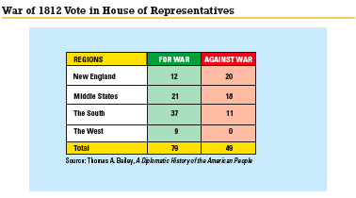

Use the chart and your knowledge of social studies to answer the following questions.

____ 68. Which of the following statements is best supported by the information in the table?
a. | The New England delegation mostly supported the war.
b. | There were few regional differences in regard to supporting the war.
c. | New England feared its cities would be blockaded by the British.
d. | Representatives from the South and the West were largely in favor of the war.

____ 69. Which of the following was a result of the War of 1812?
a. | The United States agreed to remain neutral in the European wars.
b. | Americans felt a new sense of national pride.
c. | A large section of Canada became part of the United States.
d. | New England left the Union.

McCullough v. Maryland
• Supreme Court ruling: States cannot pass a law that violates a federal law.
• Result: States could not tax the Second Bank of the United States.
Dartmouth College v. Woodward
• Supreme court ruling: The charter of Dartmouth College in New Hampshire was a private contract and protected by the Constitution.
• Result: Private businesses gained new protection.
Gibbons v. Ogden
• Supreme Court ruling: Steamboat travel between two states was interstate commerce, so only the government could regulate it.
• Result: The government of New York could not grant a steamboat company a monopoly to carry passengers on the Hudson River.

Use the information in the box and your knowledge of social studies to answer the following question.

____ 70. What was the overall result of these rulings?
a. | States could make their own financial decisions.
b. | Federal power grew and conditions for economic growth were strengthened.
c. | Private business would have a more difficult time developing.
d. | Tariffs were raised on many goods and services.

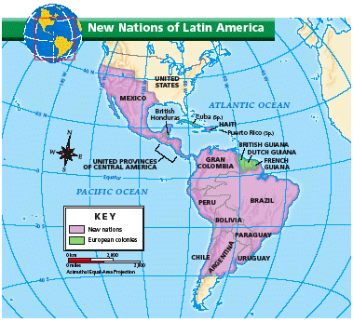

Use the information on the map and your knowledge of social studies to answer the following questions.

____ 71. What newly independent country bordered on the United States?
a. | Mexico | c. | Cuba
b. | Canada | d. | British Honduras

____ 72. What policy arose out of the changes in Latin America shown on the map?
a. | the Adams-Onis Treaty | c. | the Monroe Doctrine
b. | the Act of Union | d. | the Good Neighbor Policy

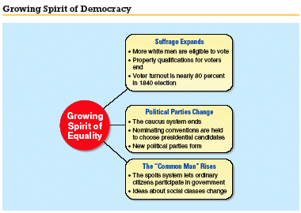

Use the information in the graphic and your knowledge of social studies to answer the following questions.

____ 73. After Jackson’s election to the presidency in 1828, why did his supporters call him “the People’s President”?
a. | More people were involved in the voting process.
b. | He invited his political opponents to his reception at the White House.
c. | Government officials were replaced with those who cold do the job better.
d. | Jackson put an end to the spoils system.

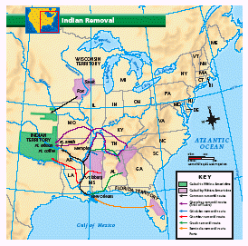

Use the map and your knowledge of social studies to answer the following questions.

____ 74. Based on the map, through which two states did the Choctaws travel to reach Indian Territory?
a. | Missouri and Arkansas | c. | Georgia and North Carolina
b. | Louisiana and Arkansas | d. | Georgia and Louisiana

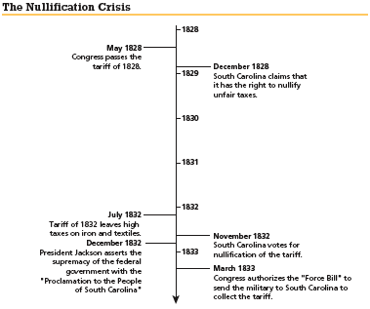

Use the timeline and your knowledge of social studies to answer the following questions.

____ 75. Which event would come next on the timeline?
a. | South Carolina repeals its tariff nullification.
b. | South Carolina secedes from the Union.
c. | Congress raises the tariff.
d. | Van Buren succeeds Jackson as president.

____ 76. In 1832, South Carolina repealed nullification after
a. | Jackson sent troops to South Carolina. | c. | Congress abandoned the protective tariff.
b. | Congress lowered the tariffs. | d. | calling a special convention.

____ 77. Which of the following did Jackson think favored the wealthy?
a. | the national debt | c. | the National Bank
b. | the right to vote | d. | the Indian Removal Act

____ 78. At the end of his time in office, President John Quincy Adams believed that
a. | the United States should not get involved in the affairs of other countries.
b. | foreign countries might attack Americans on United States soil.
c. | the federal government should not interfere with the economy.
d. | the United States was responsible for spreading democracy throughout the world.

____ 79. Which of the following warned European nations to stay out of Latin American affairs?
a. | the Dominion of Canada | c. | the Tariff of 1828
b. | the American System | d. | the Monroe Doctrine

____ 80. Suffrage is
a. | the right to vote.
b. | the right to own property.
c. | the right to move from state to state.
d. | the obligation to serve in the military in time of war.

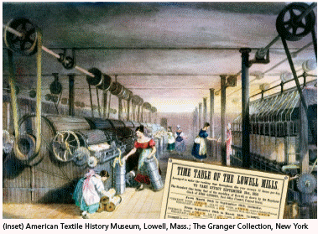

Use the picture and your knowledge of social studies to answer the following questions.

____ 81. How did the Industrial Revolution affect some children in the United States?
a. | It gave them more free time because their chores at home became easier.
b. | They worked for long hours in factories instead of going to school.
c. | They were able to visit their parents at work in the factories.
d. | It taught them new methods of production that they used on their family farms.

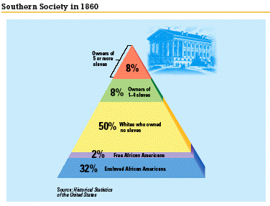

Use the diagram and your knowledge of social studies to answer the following questions.

____ 82. Slavery and cotton growing were closely linked because
a. | most cotton plantations were owned by slave traders.
b. | cotton growing required a great deal of labor.
c. | enslaved workers preferred cotton over other crops.
d. | the price of cotton was low.

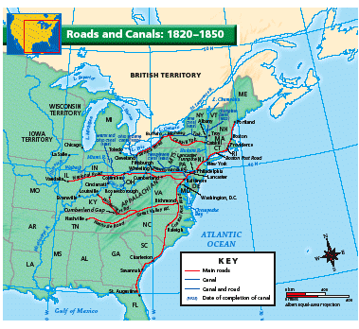

Use the map and your knowledge of social studies to answer the following questions.

____ 83. Based on the map, the National Road ran from where to where?
a. | Boston and Buffalo | c. | Baltimore and Pittsburgh
b. | Philadelphia and Lancaster | d. | Baltimore and Vandalia

____ 84. James Watt is known as the “father” of which invention?
a. | steamboat | c. | mechanical reaper
b. | steam-powered textile plant | d. | steam engine

____ 85. Which of the following occurred first?
a. | passage of the Missouri Compromise
b. | Nat Turner’s revolt
c. | invention of the telegraph
d. | completion of the National Road

____ 86. Which of the following is an example of discrimination?
a. | denying some students access to public schools because of race
b. | imposing a rating system in order to prevent young people from seeing certain movies
c. | denying a job to a person who lacks specific skills or experience for the job
d. | sending illegal immigrants back to their native country

____ 87. Irish immigrants generally were met with more hostility than some other immigrants because they
a. | were members of the Protestant church.
b. | were believed to be unwilling to work.
c. | were members of the Roman Catholic church.
d. | took most of the high paying jobs.

____ 88. Why was 1808 an important year in the fight against slavery?
a. | It became illegal to sell a freed African American back into slavery.
b. | The invention of the cotton gin replaced slave labor in many states.
c. | The slave codes were declared illegal in Kentucky.
d. | It became illegal to import enslaved Africans to the United States.

____ 89. Members of a nativist group were nicknamed “Know Nothings” because they
a. | were known to be poorly educated.
b. | campaigned against the building of public schools.
c. | replied “I know nothing” when asked about their group.
d. | did not want to learn about other cultures.

____ 90. Which of the following enabled western farmers to ship goods to New York City?
a. | Ohio River | c. | Erie Canal
b. | National Road | d. | Illinois Railroad

____ 91. Free African Americans were NOT prevented by law from
a. | sending their children to public schools.
b. | holding low paying jobs.
c. | serving on juries.
d. | testifying in court against white people.

____ 92. Who might have complained that competition with the railroads would cause them to lose money?
a. | western farmers | c. | telegraph users
b. | factory owners | d. | canal investors

____ 93. How did cotton production change in the years between 1790 and 1820?
a. | Cotton production remained almost the same from 1790 to 1820.
b. | Cotton production grew very quickly, so that it was ten times higher in 1820.
c. | Cotton production slowly declined because of the high cost of cotton gins.
d. | Cotton production shrank very quickly because of the high costs of labor.

____ 94. What did Samuel Slater bring to the United States that marked the beginning of American industrialization?
a. | a steam engine capable of powering an entire mill
b. | the raw materials used to build steam-powered textile mills
c. | his ability to build a steam-powered textile mill from memory
d. | secret information about how to build a spinning jenny

____ 95. Many Germans immigrated to America during this period because
a. | a fungus had destroyed the wheat crop in Germany.
b. | German rulers were taking away their land.
c. | they had taken part in failed revolutions against harsh rulers.
d. | they lacked the skills necessary to get good jobs in Germany.

____ 96. What was a major advantage of railroads compared to other kinds of transportation?
a. | Traveling by railroad was very safe.
b. | Railroads could be built almost anywhere.
c. | Railroads could be built quickly.
d. | Railroads did not harm the environment.

____ 97. Which of the following were all cotton producing states?
a. | Alabama, Tennessee, Mississippi, Vermont
b. | New York, New Jersey, Maine, Ohio
c. | Tennessee, Mississippi, Alabama, Louisiana
d. | Louisiana, Alabama, Mississippi, Connecticut

____ 98. By the 1850s, which of the following linked many towns with cities and factories and opened new markets for the northern economy?
a. | wagon routes | c. | clipper ships
b. | telegraphs | d. | railroads

____ 99. Which of the following was part of the Missouri Compromise?
a. | Slave owners would not be allowed to pursue slaves who escaped to “free” territory.
b. | The Louisiana Territory north of the southern border of Missouri would be free of slavery.
c. | All children born to enslaved people in Missouri would be free.
d. | No additional slaves could be brought into Missouri after its admission to the Union as a slave state.

____ 100. Which of the following opinions would a nativist be most likely to express?
a. | “The knowledge gained from studying other cultures is valuable.”
b. | “America belongs only to white Protestants born in the United States.
c. | “Citizens of the United States should be proud of this country’s history of welcoming immigrants.”
d. | “We should seek to promote equal opportunity for all people.”

Directions: Use the quotation and your knowledge of social studies to answer the questions.

“We went every day . . . with our books wrapped in paper to prevent the police or white persons from seeing them.”
—from the memoir of a free African American living in the North

____ 101. Which of the following does the word We most likely represent?
a. | African-American workers | c. | enslaved African American children
b. | African American children in the South | d. | free African American children

____ 102. The speaker probably wanted to hide the books because
a. | he could not read.
b. | the police would think the books were stolen.
c. | he might face discrimination from people who saw the progress of African Americans as a threat.
d. | African Americans were not proud of their schools.

____ 103. Which of the following allowed Missouri to enter the Union as a slave state and Maine to enter the Union as a free state?
a. | the Missouri Compromise | c. | the Industrial Revolution
b. | increased immigration | d. | urbanization

____ 104. Most southern whites were
a. | farmers. | c. | factory workers.
b. | industrialists. | d. | slaves.

____ 105. Which of the following was NOT a result of the invention of the cotton gin?
a. | Cotton profits increased enormously.
b. | Cotton growers used profits to build more textile mills.
c. | Cotton production increases required more slaves.
d. | Cotton plantations extended as far west as Texas.

____ 106. Which of the following could be made with interchangeable parts?
a. | toasters | c. | paintings
b. | needles | d. | spoons

Directions: Use the graph to answer the following questions.

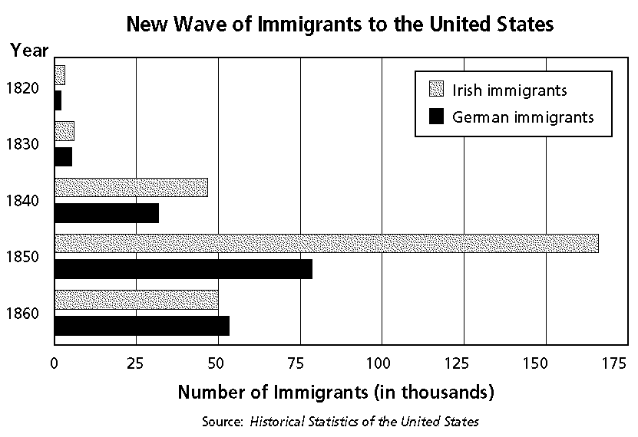

____ 107. In which year was the number of Irish and German immigrants almost exactly the same?
a. | 1820 | c. | 1840
b. | 1830 | d. | 1860

____ 108. Which of the following statements is supported by the information on the graph?
a. | Irish and German immigration constantly increased between 1840 and 1860.
b. | Irish and German immigration constantly fell between 1840 and 1860.
c. | Irish and German immigration stayed at constant levels between 1840 and 1860.
d. | Irish and German immigration first increased and then fell between 1840 and 1860.

Directions: Use the map to answer the following questions.

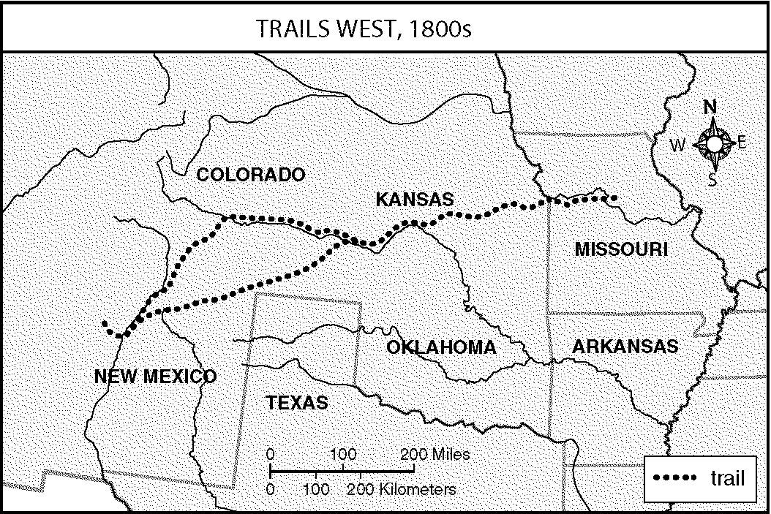

____ 109. Who were the first travelers along this route?
a. | farmers | c. | traders
b. | fur trappers | d. | mountain men

____ 110. Why did American settlers in Texas come into conflict with Mexico in the 1830s?
a. | Settlers wanted more representation in the Mexican legislature.
b. | Mexico wanted to sell Texas to Spain.
c. | Mexico feared losing Texas to the United States.
d. | Settlers wanted to outlaw slavery.

____ 111. Women in the West often had more rights than women in other regions of the United States because
a. | their labor was needed for their families to survive.
b. | they could negotiate treaties.
c. | they could vote and run for office.
d. | their labor was more important than men’s.

____ 112. The idea of Manifest Destiny was a cause of all of the following EXCEPT
a. | the Mexican-American War. | c. | the Texas War of Independence.
b. | the annexation of Oregon. | d. | the westward movement.

____ 113. How was Texas admitted to the Union?
a. | The President issued an executive order accepting the annexation treaty.
b. | Congress passed a joint resolution accepting the annexation treaty.
c. | Mexico sold Texas to the United States.
d. | Sam Houston forced Mexico to give Texas to the United States.

____ 114. Which statement BEST explains why California developed a diverse population?
a. | Many English-speaking settlers migrated there from eastern states.
b. | Many Chinese people migrated there to work on the railroad.
c. | State laws banning racial discrimination attracted many African Americans.
d. | Gold seekers came from all over the world and became permanent residents.

____ 115. What is the significance of the siege at the Alamo?
a. | The siege ended when Texan soldiers defeated Santa Anna, ending the Mexican-American War.
b. | The heroism of Mexican soldiers during the siege inspired many Mexicans to join Santa Anna’s army.
c. | It was the attack which officially began the Mexican-American War.
d. | It was the site where Texans were overrun by Mexican troops, inspiring many Americans to volunteer for the Texan army.

____ 116. The “mountain men” of the Oregon Territory were
a. | fishermen. | c. | trappers.
b. | miners. | d. | ranchers.

____ 117. Which of the following statements about New Spain is true?
a. | The Spanish and the Native Americans borrowed language, foods, and customs from each other.
b. | The Spanish and the Native Americans both opposed slavery.
c. | The Spanish and the Native Americans shared political power in California.
d. | The Spanish and the Native Americans were constantly at war with each other.

____ 118. Which of the following did the United States acquire as a result of the Mexican-American War?
a. | Oregon | c. | New Mexico
b. | North Dakota | d. | Washington

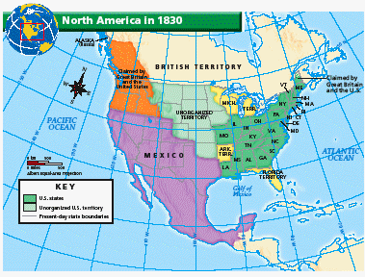

Use the map and your knowledge of social studies to answer the following questions.

____ 119. When John L. O’Sullivan proposed the idea of Manifest Destiny, which other nation held the most territory in the present-day United States?
a. | Great Britain | c. | Spain
b. | Mexico | d. | Russia

____ 120. Why did most Americans think the United States should extend to the Pacific Ocean?
a. | They believed it was their right to possess this land.
b. | They feared invasion by Mexico.
c. | They wanted to make sure Great Britain did not claim the land.
d. | They had already settled the lands of the Great Plains and needed more room.

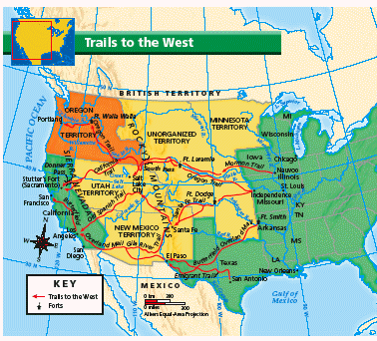

Use the map and your knowledge of social studies to answer the following questions.

____ 121. Easterners going to the Great Salt Lake were most likely to take the
a. | Old Spanish Trail. | c. | Santa Fe Trail.
b. | Mormon Trail. | d. | Oregon Trail.

Events Leading to the Mexican-American War
• Texas gains independence.
• Mexico claims the border between Mexico and Texas is at the Nueces River.
• The United States annexes Texas.
• The United States offers to pay Mexico to set the Texas-Mexico border farther south, at the Rio Grande.
• President Polk sends General Zachary Taylor to the disputed Rio Grande border.
• Mexican troops attack a U.S. army patrol.
• Claiming that Mexico shed “American blood upon American soil,” President Polk asks Congress to declare war.

Use the information in the box and your knowledge of social studies to answer the following questions.

____ 122. What effect did the Treaty of Guadalupe-Hildalgo have on the United States?
a. | The United States recognized the Mexican border at the Nueces River.
b. | The United States paid Mexico $10 million for land in Arizona and New Mexico.
c. | Texas gained independence from Mexico and became a republic.
d. | Mexico ceded a large area of territory to the United States.

Growing Tensions Over Slavery, 1820–1850
1820 — Missouri Compromise bans slavery north of 36º30’ N Louisiana Territory.
Maine is admitted as a free state.
1821 — Missouri is admitted as a slaveholding state.
1845 — Texas is admitted as a slaveholding state.
1847 — Popular sovereignty is proposed to determine whether slavery should be allowed in each new territory.
1848 — Free Soil Party forms to support the banning of slavery in all territory gained in the Mexican-American War.
1848 — Nation is divided between 15 free states and 15 slaveholding states.

Use the time chart and your knowledge of social studies to answer the following questions.

____ 123. Which of the following could be added to the time chart?
a. | 1848–Senator Lewis Cass runs for president on the Free-Soil ticket.
b. | 1850–Congress turns down Clay’s compromise.
c. | 1846–Wilmot Proviso proposes banning slavery in land gained from Mexico.
d. | 1850–Whigs and Democrats debate Clay’s compromise in Congress.

____ 124. Why did the admission of California alarm Southerners?
a. | It upset the balance between free and slave states in the Senate.
b. | It gave California more representatives than other states in Congress.
c. | Southerners feared the slave trade in California would end.
d. | It overturned the Missouri Compromise.

“Did John Brown fail? He certainly did fail to get out of Harpers Ferry before being beaten down by United States soldiers; he did fail to save his own life and to lead a liberating army into the mountains of Virginia. But he did not go to Harpers Ferry to save his life.
“The true question is, Did John Brown draw his sword against slavery and thereby lose his life in vain? And to this I answer ten thousand times, No! No man fails, or can fail, who so grandly gives himself and all he has to a righteous cause.”
—Frederick Douglass, 1881

Use the excerpt and your knowledge of social studies to answer the following questions.

____ 125. Who was Frederick Douglass?
a. | a former Republican presidential candidate
b. | a member of Congress who opposed the Compromise of 1850
c. | a former slave who escaped and became an abolitionist
d. | a member of John Brown’s band who was not sentenced to death

____ 126. Why did Brown mount his raid on Harper’s Ferry?
a. | to free African Americans who had been captured by the U.S. Army
b. | to raise an army of African Americans and lead them in a revolt
c. | to protest the Pottawatomie Massacre in Kansas
d. | to demonstrate that he sided with Northerners in the debate over slavery

“In your hands, my dissatisfied fellow countrymen, and not in mine is the momentous issue of . . . war. The government will not assail [attack] you. . . We are not enemies, but friends. We must not be enemies. Though passion may have strained, it must not break our bonds of affection.”
—Abraham Lincoln, Inaugural Address, March 4, 1861

Use the excerpt and your knowledge of social studies to answer the following questions.

____ 127. Which “dissatisfied fellow countrymen” did Lincoln refer to?
a. | Democrats who had supported Stephen A. Douglas
b. | Whigs who had stayed 0ut of the Republican party
c. | southerners whose states had seceded
d. | northerners who urged Lincoln to attack the South

____ 128. Southerners attacked Fort Sumter because they believed that
a. | Lincoln was arming the fort.
b. | war was inevitable so it was better to start it on their own terms.
c. | the British were preparing to seize the fort.
d. | the capture of the fort would force Lincoln to resign.

____ 129. California’s request to join the Union in 1850 would have
a. | given free states an advantage over slave states.
b. | given slave states an advantage over free states.
c. | extended slavery into a territory acquired from Mexico.
d. | restored the balance between free and slave states.

____ 130. How did the South react to Abraham Lincoln’s election as President in 1860?
a. | To save the Union, Southern leaders agreed to support the new President.
b. | North Carolina and Virginia seceded, followed by South Carolina.
c. | Seven Southern states seceded and formed the Confederate States of America.
d. | Southern leaders called for a new presidential election to be held in the spring.

____ 131. Senator John C. Calhoun would most likely agree with which of the following statements?
a. | Preserving the Union is more important than states’ rights.
b. | States’ rights are more important than preserving the Union.
c. | The federal government should have the power to decide whether states allow slavery.
d. | New territories should be allowed to determine for themselves whether to allow slavery.

____ 132. Which of the following was not a direct cause of the Civil War?
a. | Seven southern states seceded from the Union.
b. | Abraham Lincoln was elected President in 1860.
c. | Confederate troops attacked Fort Sumter.
d. | Union troops attacked Confederate forts in South Carolina.

____ 133. California entered the Union as a free state in the
a. | Wilmot Proviso. | c. | Compromise of 1850.
b. | the Missouri Compromise. | d. | Kansas-Nebraska Act.

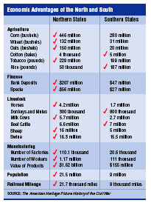

Use the information in the chart and your knowledge of social studies to answer the following questions.

____ 134. Which statement best summarizes the information in this chart?
a. | The North had more advantages in the area of agriculture.
b. | The South had more livestock but the North had more money.
c. | The North had advantages over the South in nearly all resources.
d. | The North had a much greater population than the South.

____ 135. Which listing on the chart indicates that the North had a more industrialized economy?
a. | agriculture | c. | livestock
b. | finance | d. | manufacturing

A letter from a Union Soldier Aboard the Monitor to his Family Describing the Battle of the Ironclads
“This [the ramming by the Merrimack] was the critical moment, one that I had feared from the beginning of the fight—if she could so easily pierce the heavy oak beams of the Cumberland [another Union ship] she surely could go through the 1/2 inch iron plates of our lower hull. A moment of terrible suspense, a heavy jar nearly throwing us from our feet—a rapid glance to detect the expected gush of water— she had failed to reach us below the water & we were safe. The sounds of the conflict at this time were terrible. The rapid firing of our own guns amid the clouds of smoke. . .mingled with the crash of solid shot against our sides & bursting of shells all around us. . . .I think we get more credit for the mere fight than we deserve, any one could fight behind an impenetrable armour—many have fought as well behind wooden walls or behind none at all.”
William F. Keeler, March 1862

Use the excerpt and your knowledge of social studies to answer the following questions.

____ 136. What conclusion can be drawn from this first battle of the ironclads?
a. | The North’s navy was stronger than the South’s.
b. | New technology would be of little help in the war.
c. | The era of wooden warships was at an end.
d. | The Merrimack drove the Monitor away from Virginia’s shores.

____ 137. Which of the following statements is a fact that Keller expresses in his letter?
a. | The soldiers got more credit for defending their ship than hey deserved.
b. | Both the northerners and the southerners fought with guns and cannons.
c. | The Merrimack did not succeed in sinking the Monitor.
d. | The soldiers fought a better battle than many others had doe before them.

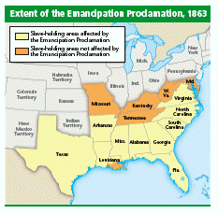

Use the map and your knowledge of social studies to answer the following questions.

____ 138. Some abolitionists complained that the Emancipation Proclamation did not apply to all states. Based on the map, what do you think were Lincoln’s motives in limiting the reach of the Emancipation Proclamation?
a. | He wanted to ensure the freedom of all slaves in the South.
b. | He wanted to hurt the southern war effort in those areas not under Union control.
c. | He hoped to make Louisiana half slave and half free.
d. | He wanted to give slaves a reason to escape and join the Union army.

The Draft in the North |  | The Draft in the South
• established in March 1863 |  | • established in April 1862
• applied to white men aged 20 to 45 |  | • applied to white men aged 18 to 35 (later expanded to men aged 17 to 50)
• avoidable by paying the government $300 |  | • did not apply to men owning at least 20 slaves
• allowed draftees to hire substitutes |  | • allowed draftees to hire substitutes
• did not apply to African Americans, but they could volunteer for service |  | • applied to slaves, beginning in 1865

Use the information in the chart and your knowledge of social studies to answer the following questions.

____ 139. Which of the following indicates that the South was not doing well in the war?
a. | The draft in the South did not apply to men owning at least 20 slaves.
b. | The draft in the South was eventually applied to slaves.
c. | The draft in the South did not allow people to pay someone to serve in their place.
d. | The draft in the South was established after the draft in the North.

____ 140. What is the most likely reason that the Union army did not draft African Americans?
a. | Union leaders feared it would turn northern whites against the war.
b. | The North had a large population so the military did not need more soldiers.
c. | Few African Americans lived in the North.
d. | Most African Americans in the North had already volunteered for military service.

____ 141. Which of the following statements is true about the effect of the war?
a. | Trade between the South and Europe increased greatly.
b. | Prices of goods rose in both the North and the South.
c. | Northern factories produced less and less.
d. | The North’s economy was hurt more than South’s economy.

____ 142. During the Civil War, African American troops
a. | fought on the Union side in large numbers.
b. | were not allowed into battle.
c. | were very few in number.
d. | did not face discrimination.

____ 143. After the first battle at Bull Run
a. | Robert E. Lee knew that he would quickly defeat the North.
b. | Ulysses S. Grant was made commander of the Union army.
c. | the North and the South realized that the war would be a long, hard struggle.
d. | Lincoln realized that the war would be even shorter than he had thought.

____ 144. Which of the following statements is true?
a. | The war might have been shorter if Ulysses S. Grant had been more willing to fight.
b. | Robert E. Lee believed that his best strategy was to never invade the North.
c. | Jefferson Davis refused to suspend the right of habeas corpus.
d. | Abraham Lincoln’s main goal was to reunite the nation.

____ 145. By 1865,
a. | the South’s economy was strong because the war had helped its industries.
b. | large parts of the North were destroyed because of invasions by Lee’s army.
c. | Northern armies were doing very little damage to the South.
d. | parts of the South lay in ruins because of the North’s strategy of total war.

Completion
Complete each statement.

146. In 1789, the United States was about ________ its current size.

147. Alexander Hamilton and Thomas Jefferson disagreed about the power of the federal
government. ________ wanted the federal government to have more power than the
state governments.

148. Alexander Hamilton and Thomas Jefferson also differed over foreign policy. Jefferson
supported ________, the nation that supported the United States during the American
Revolution.

149. In the Election of 1796, John Adams became the second President; he was a ________.

150. Vice President Thomas Jefferson was a ________.

151. Republicans tended to be more supportive of ________, while the Federalists supported
Britain.

152. In his farewell address, George Washington warned against the dangers of political
________.

153. The actions of George Washington, Thomas Jefferson, and other leaders of the United
States were important because they helped determine how the __________ _________ would
work.

154. After much discussion about whether the Constitution allowed it, the ________ of the
________ ________was set up in 1791 to issue paper money and make loans to
farmers and businesses.

155. A tax on liquor led to the ________ ________, which marked the first time the
government sent troops to fight American citizens.

156. Thomas Jefferson believed that under the Federalists, ________ had become too large
and powerful.

157. Thomas Jefferson reduced the power of the federal government in economic affairs by
promoting ________.

158. Chief Justice ________ ________ wrote the decision that declared the Judiciary Act of
1789 unconstitutional.

159. The precedent set in the case of ________ v. ________ gave the Supreme Court the right to decide
whether laws passed by Congress were constitutional.

160. One of the most important powers of the Supreme Court today is ________ ________.

161. Thomas Jefferson ordered a(n) ________ to force Britain and France to respect American neutrality

162. Francis Scott Key wrote “The Star-Spangled Banner” after watching the battle at ________.

163. The War of 1812 ended with the Treaty of ________.

164. Opponents to the war suggested that New England states ________.

165. Britain and France interfered with American neutrality by ________.

166. The Native American population declined with the arrival of white settlers because the
settlers ________ and ________.

167. Tecumseh organized the Shawnee and other Native Americans to ________ and
________.

168. One disadvantage the United States faced at the beginning of the War of 1812 was a ________.

169. Roads, bridges, and canals are part of a region’s ________.

170. Henry Clay thought the country would benefit from his ________
System.

171. The Supreme Court decision in Dartmouth College v. Woodward favored the system
of ________.

172. The country that controlled the most territory in the Americas was ________.

173. Spanish towns in Florida were attacked by the troops of ________ ________.

174. Because of his role in leading independence movements, Simón Bolívar is called
the ________.

175. The statement that was intended to protect newly independent nations in Latin America
is called the ________ ________.

176. The Native Americans that had adopted more white customs than any other group were
the ________.

177. The plan to move Native Americans west of the Mississippi originated with ________
________.

178. The Cherokees brought their fight to the Supreme Court with Cherokee Nation v.
________.

179. The removal of the Cherokees was actually carried out during the term of President
________.

180. The law President Andrew Jackson used to get around the Court’s decision was the
________.

181. The route the Cherokees took when the U.S. government forced them to move to
Oklahoma was the ________.

182. The spread of urbanization and a sharp rise in ________ caused problems in many
northern cities.

183. Advances in technology and many new ________ helped the growth of industry.

184. Businesses could obtain raw materials and get goods to market more easily because of
improvements in ________.

185. Free African Americans in the North often faced ________ and were denied many rights.

186. The question of the admission of ________ to the Union as a free state led to the
Compromise of 1850.

187. The Compromise of 1850 allowed California to join the United States as a free state
and passed a strict ________, which allowed escaped slaves in the North to be
recaptured.

188. _______ suffered widespread violence as proslavery and antislavery settlers fought for
control of the territory.

189. The ________ Act allowed settlers in the territories to decide whether to allow slavery.

190. The western counties of ________ refused to secede and later formed a new state.

191. Leadership by the most experienced military officers was an advantage held by the
________.

192. One of the great tragedies of the war was that it divided ________.

193. Expectations of a quick victory were dashed for both sides at ________.

194. Soldiers on both sides faced harsh conditions, ________, and if captured, starvation
and exposure in prison camps.

195. The Monitor and the Merrimack were examples of ________, which changed the nature
of naval warfare.

196. General Robert E. Lee decided to invade ________ when General George McClellan
was forced to retreat near Richmond.

197. General McClellan was able to block General Lee at ________ because he knew the
Confederate army was divided into two parts.

198. General Ulysses S. Grant was able to capture two important ________ in the western
Confederacy.

199. The Union army gained control of western Tennessee after the ________.

200. After Admiral David G. Farragut captured New Orleans, the Union army gained control
of almost all of ________.

201. General ________ was confident in victory before his army was crushed at
Chancellorsville.

202. The Union forces won major battles at ________ and Gettysburg that helped them gain
the upper hand in the war.

203. In 1864 Ulysses S. Grant became the commander of all the ________ forces.

204. The fall of Richmond led Robert E. Lee to ________, bringing an end to the war.

205. About ________ soldiers lost their lives in the Civil War, making it the bloodiest
conflict the United States has ever fought.

Matching

Match each item with the correct statement below:

a. | speculator | e. | Anthony Wayne
b. | James Madison | f. | alien
c. | XYZ Affair | g. | John Jay
d. | John Adams | h. | explorer

____ 206. an outsider or someone from another country

____ 207. the first chief justice of the Supreme Court

____ 208. a person who buys things hoping the price will rise and that he or she will make a profit

____ 209. a general who defeated Native American tribes in the Battle of Fallen Timbers

____ 210. an attempt by the French to bribe Americans seeking to stop French attacks on American merchant ships

Match each item with the correct statement below:

a. | Simón Bolívar | e. | interstate commerce
b. | caucus | f. | Martin Van Buren
c. | John C. Calhoun | g. | Adams-Onís Treaty
d. | Monroe Doctrine | h. | nominating convention

____ 211. gave control of Florida to the United States

____ 212. private meeting during which a small group of party members pick candidates

____ 213. in office during the Panic of 1837

____ 214. trade between two or more states

____ 215. led independence movements in Latin America

Match each item with the correct statement below:

a. | capitalists | e. | Missouri Compromise
b. | Samuel Slater | f. | Nat Turner
c. | Eli Whitney | g. | Erie Canal
d. | nativists | h. | railroad system

____ 216. connected markets in New York and the Midwest

____ 217. plan to maintain the balance of slave states and free states

____ 218. group that wanted laws to limit immigration

____ 219. developed the system of interchangeable parts

____ 220. brought plans to America for the first textile factory

Match each item with the correct statement below:

a. | vigilante | e. | Oregon Trail
b. | mountain man | f. | dictatorship
c. | land grant | g. | Brigham Young
d. | John C. Frémont | h. | Antonio López de Santa Anna

____ 221. Mormon leader who led settlers to Utah

____ 222. government gift of land

____ 223. one-person rule

____ 224. self-appointed law enforcer

____ 225. explorer in California who led a rebellion against Mexico

Match each item with the correct statement below:

a. | Abraham Lincoln | e. | Roger Taney
b. | secede | f. | popular sovereignty
c. | propaganda | g. | Daniel Webster
d. | John C. Calhoun | h. | John Brown

____ 226. abolitionist who led a raid on U.S. Army weapons stored at Harpers Ferry

____ 227. false or misleading information that is spread to further a cause

____ 228. candidate for the Senate who argued against the spread of slavery

____ 229. process that allows people in a territory or state to vote directly on issues rather than have their elected representatives decide

____ 230. senator from South Carolina who opposed the Compromise of 1850

Essay

231. What are two of the challenges that George Washington faced during the beginning of
his presidency?

232. How did the Federalists and Republicans interpret the Constitution differently?

233. Name two ways in which the actions of Britain and France affected the United States.

234. What goals did Lewis and Clark accomplish on their expedition?

235. Describe the impact of the independence movement in the United States on Latin
America.

236. Give two examples of how people gained more power during the Age of Jackson.

237. What were the causes of the Panic of 1837?

238. Evaluate the presidency of Andrew Jackson. Decide which of his policies or actions benefited the nation and which were not in agreement with the principles of the United States government. Explain your conclusions with examples from the text.

239. Explain how political changes influenced the growing democratic spirit in the United States by the 1840s. Be sure to use examples and details from the text.

240. How did the Industrial Revolution change the way people worked?

241. Analyze the effects of the Industrial Revolution on the United States. Then, explain the economic changes it brought to the nation, its impact on women and daily life, and its impact on population trends.

242. What were two events that fueled the debate over slavery between 1846 and 1850?

243. How did northerners react to the Compromise of 1850?

244. Describe the agreements reached between the United States and Mexico after the Mexican-American War. Then, evaluate whether or not the United States and Mexico benefited from the agreements. Be sure to provide details from the text.

245. In an essay, compare the experiences of the people of different cultures who settled in California in the 1840s and 1850s. Include in your essay how the increase in immigrant populations affected Mexican Americans and Native Americans who lived in California before the Mexican Cession.

246. How did northerners react to the Compromise of 1850?

247. Explain how the Dred Scott decision widened the gap between the North and the South. In your opinion, was the Dred Scott decision one of the most important Supreme Court decisions in history? Give specifics to support your argument.

248. What advantages did General Grant’s armies gain for the North?

249. How were soldiers and civilians affected by the war?

250. How did Abraham Lincoln foresee the outcome of the war in his Gettysburg Address?

